BIOL/CHEM 3361 Name__________________________
Fall 2010
EXAM 2
FORM A

Place your name at the top of this page of the exam. On the F-1712 Scantron form, use a no. 2 pencil to enter your test form designation, i.e., A or B. Also print and encode your name and last 6 digits of your UTD ID (starting in the first column on the left and leaving the last spaces blank). Leave phone number, code and subject score sections blank.
Select the best answer for the following multiple-choice questions and enter the corresponding letter on the Scantron sheet. You may use these test pages to make notes and work problems.
You may use a non-graphing calculator or a graphing calculator you have cleared of all stored data.
When finished, turn in this exam along with your Scantron sheet.

1. The α helices of a protein are examples of
- primary structure
- secondary structure
- supersecondary structure
- tertiary structure
- quaternary structure

2. The ψ angle refers to the amount of rotation about which bond(s) in the peptide backbone?
a. N-C_{α}
b. C_{α}-C_{carbonyl}
c. C_{carbonyl}-N
d. N-H
e. C_{α}-C_{β}

3. The average packing density of a protein (credit given for either answer)
a. is near the maximum that is possible
b. is 0.74
c. accounts for large areas occupied by water in the interior of proteins
d. a and b
e. b and c

4. The term NACs as coined by Thomas Bruice refers to
a. the catalytic triad NAC (i.e., Asn-Asp-Cys)
b. catalysis by proximity
c. catalysis by orientation
d. a and c
e. b and c

5. What is the transition state geometry of the carbonyl carbon of a peptide bond during chymotrypsin- catalyzed hydrolysis?
a. planar
b. triangular
c. tetrahedral
d. pentagonal
e. bipyramidal

6. Which of the following will denature a protein?
- sucrose
- urea
- sodium chloride
- b and c
- all of the above

7. Intrinsically unstructured proteins (IUPs) often
a. serve as docking proteins for formation of protein complexes
b. are Michaelis enzymes
c. contain more than the average number of charged residues
d. a and b
e. a and c

8. The π helix (aka 4.4₁₆) differs from the α helix in its
a. number of residues per repeat of the helix
b. pitch
c. handedness
d. a & b
e. all of the above

9. The HIV protease is proposed to function by
- general acid-base catalysis facilitated by a low barrier H-bond
- covalently linking to the acyl portion of the substrate
- coordination of the substrate to a zinc ion
- specific base catalysis
- Schiff base formation

10. Sulfa drugs are analogs of p-aminobenzoic acid. They function by
a. competitively inhibiting biotin synthesis
b. uncompetitively inhibiting biotin synthesis
c. irreversibly inhibiting folic acid synthesis
d. competitively inhibiting folic acid synthesis
e. noncompetitively inhibiting folic acid synthesis

11. For a bisubstrate reaction, a Lineweaver-Burk plot consisting of a set of parallel lines is characteristic of
a. an ordered single displacement reaction.
b. a random single displacement reaction.
c. a ping pong double displacement reaction.
d. a random triple displacement reaction
e. none of the above.

12. Consider the β-sheet oligopeptide, DATMCATLSAT, which is part of a protein. Which of the following properties is it most likely to have?
a. antiparallel with As on one side of the sheet and Ts on the other
b. antiparallel with As alternating between sides of the sheet
c. parallel with Ts exposed to the solvent
d. parallel with As exposed to the solvent
e. parallel with Ts alternating between sides of the sheet

13. Zn²⁺ catalysis can involve
- H⁺ donation to the substrate
- OH⁻ donation to the substrate
- induction of electronic strain in the substrate
- a and c
- b and c

14. Viagra competitively inhibits the phosphodiesterase that is involved in stopping penile erection. This drug is a mimic of
a. cAMP
b. cCMP
c. cGMP
d. cTMP
e. cUMP

15. Which of the following is not a way enzymes catalyze reactions?
a. lowering the Arrhenius activation energy
b. forming better weak interactions with the transition state than with the substrate
c. reducing the standard state free energy change for the reaction
d. acylating the side chain of serine
e. introducing geometric strain in the substrate

16. For an enzyme that obeys Michaelis-Menten kinetics, what is V_{max} if v = 25 μmoles/min
when [S] = K_{m} ?
a. 50 μmol/min
b. 70 μmol/min
c. 140 μmol/min
d. 175 μmol/min
e. 205 μmol/min

17. Aspartic and serine proteases belong to which class of enzymes?
a. oxidoreductase
b. transferase
c. isomerase
d. hydrolase
e. lyase

18. Which of the following statements is true about uncompetitive inhibition?
a. K_{m} is unchanged
b. V_{max} is unchanged
c. V_{max} and K_{m} increase
d. V_{max} and K_{m} decrease
e. K_{I} is the same for E and ES

19. Lineweaver-Burk plots (aka. double reciprocal plots) can be used to
a. determine K_{m} values
b. distinguish between single and double displacement reaction mechanisms
c. distinguish between competitive and noncompetitive inhibitors
d. determine K_{i} if [I] is known
e. all of the above

20. A measure of the specificity and efficiency of an enzyme is given by
a. k_{cat}/K_{m}
b. k_{cat}[E]_{total}
c. k₁/k₋₁
d. (k₋₁ + k_{cat})/k₁
e. the rate of catalysis at low [S]

21. If the active site of an RNase contains a two histidine residues (pK_{a}s 5.8 and 7.0), one of which must be charged and the other uncharged for catalysis to occur, what is the optimal pH for catalysis?
a. 4.8
b. 5.8
c. 6.4
d. 6.6
e. 8.0

22. Which of the following residues near a histidine in the active site of an enzyme would tend to lower the pKa of the histidine side chain?
a. leucine and phenylalanine
b. aspartate
- glycine
- asparagine
- all of the above

23. The polyproline-like collagen helix is a type of
a. sheet structure
b. domain structure
c. secondary structure
d. super-secondary structure
e. random coil

24. An enzyme has an apparent K_{m} of 1 x 10⁻³ M and a V_{max} of 1 x 10⁻⁴ moles/min. in the presence of 1 x 10⁻³ M competitive inhibitor (K_{I} = 1 x 10⁻⁷ M). What is the true K_{m} of the enzyme?
a. 1 x 10⁻⁷ M
b. 1 x 10⁻⁶ M
c. 1 x 10⁻⁵ M
d. 1 x 10⁻⁴ M
e. 1 x 10⁻³ M

25. The turnover number of an enzyme is also known as
- k₋₁
- k_{cat}
- k_{cat}/K_{m}
- (k₋₁ + k_{cat})/k₁
- K_{m}

26. General acid catalysis begins by
a. electrophilic attack by the conjugate base
b. addition of H⁺ to the substrate
c. withdrawal of OH⁻ from the substrate
d. withdrawal of H⁺ from the substrate
- withdrawal of a hydrogen from the substrate

27. Enzymes that are classified as lyases catalyze reactions in which
- a there is a rearrangement of groups in a molecule
- energy from ATP hydrolysis drives the reaction
- molecules exchange functional groups
- there is an addition to a double bond without ATP hydrolysis
- molecules exchange electrons

28. To be activated, organophosporus insecticides such as malathion must
a. be hydrolyzed
b. be joined to glutamic acid
c. have a phosphorus-bound sulfur replaced with oxygen
d. be reduced
e. have an acetyl group added to it

29. Connections between strands of a β sheet
- are always β bends
- are always random coil
- are usually right handed
- are usually left handed
- none of the above

30. Enzymes with kinetics that produce an S-shaped (i.e., sigmodal) curve on a v_{o} vs. [S] plot are
a. Michaelis-Menten enzymes
b. Lineweaver-Burk enzymes
c. perfect enzymes
d. Scatchard enzymes
e. allosteric enzymes

31. The fibrous α-keratin polypeptides found in hair, skin, cytoskeleton, etc. associate with one another by forming a
a. left-handed coiled coil
b. left-handed propeller
- greek-key cylinder
- barrel
- right–handed sandwich

32. Which of the following statements is false?
a. Peptide bonds have a partially double bond character.
b. Peptide bonds form planar structures.
c. Most peptide bonds are fully H-bonded in native proteins.
d. Peptide bonds can accept H⁺ to become positively charged.
e. Most peptide bonds have a trans configuration in native proteins.

33. Which of the following amino acid residues can participate in catalysis by formation of an unstable covalent intermediate?
a. trp
b. phe
c. cys
d. met
e. gln

34. The cellular concentration of the substrate of an enzyme is often found to be
- much less than its K_{m} value
- approximately equal to its K_{m} value
- much greater than its K_{m} value
- equal to k_{cat}/K_{m}
- equal to k_{cat}

35. How many amino acid residues will there be in a four-strandedantiparallel β-sheet that is 2.8 nm long? Do not include the residues in the turns connecting the strands of the sheet.
a. 25
b. 20
c. 16
d. 12
e. 32

36. Which standard amino acid residue in proteins is often found in areas of a Ramachandran plot which are energetically unfavorable for L-amino acids?
a. A
b. P
c. G
d. T
e. W

37. The Hsp60 proteins or chaperonins
- serve as prolyl isomerases
- serve as templates for protein folding
- clamp down on hydrophobic residues in newly made proteins
- only help proteins fold correctly after heat shock
- form molecular vessels in which proteins can fold in isolation

38. What kind of plot do biochemists typically use to determine the number of binding sites for a ligand on a protein and its dissociation constant?
- Hanes-Woolf
- Eadie-Hofstee
- Scatchard
- Koshland
e. Michaelis-Menton

39. Which of the following can serve as a general acid catalyst?
a. A
b. D
c. Q
d. F
e. T

40. Which of the following super-secondary structures can be found in β-barrels?
a. helix-loop-helix
b. β-hairpins (i.e., β-meanders)
c. β-α-β
d. a & c
e. b & c

41. Five noncompetitive inhibitors of an enzyme were found to exhibit the following K_{I} values. Which is the worst inhibitor?
a. K_{I} = 1 x 10⁻² M
b. K_{I} = 3 x 10⁻³ M
c. K_{I} = 3 x 10⁻⁵ M
d. K_{I} = 7 x 10⁻⁸ M
e. K_{I} = 5 x 10⁻⁹ M

42. The Briggs and Haldane derivation of the generalized kinetic equation for a Michaelis-Menten enzyme differs from the original Michaelis-Menten derivation by the assumption that
- the product concentration is insignificant
- the enzyme-substrate complex concentration does not change with time, i.e., it’s in steady state
c. the substrate concentration is large and does not change significantly with time
d. the free enzyme concentration is always in great excess to the concentration of the enzyme-substrate complex
e. the substrate-enzyme complex rapidly equilibrates with the free substrate and enzyme

43. If an isomerase (M_{r} 30,000) at a concentration of 0.12 μg/ml and one active site per molecule
has a V_{max} of 1.2 x 10⁻⁵ M/min, what will its turnover number be?
a. 1.2 x 10² /min
b. 1.2 x 10³ /min
c. 3.0 x 10³ /min
d. 4.8 x 10³ /min
e. 5.1 x 10⁴ /min

44. If the concentration of the isomerase in the previous question is decreased to 0.03 μg/ml, what will the V_{max} be?
a. 2.4 x 10⁻⁵ M/min
b. 3.0 x 10⁻⁵ M/min
c. 7.5 x 10⁻⁵ M/min
d. 3.0 x 10⁻⁶ M/min
e. 6.0 x 10⁻⁶ M/min

45. For a Michaelis-Menten enzyme , k₁ = 2 x 10⁹ M⁻¹ s⁻¹, k₋₁ = 5 x 10⁴ s⁻¹, and k₂ = 4 x 10² s⁻¹. What is the K_{m} for this reaction.?
a. 0.8 x 10⁻² M
b. 2.5 x 10⁻⁵ M
c. 2.0 x 10⁻⁷ M
d. 2.0 x 10⁻⁹ M
e. 1.2 x 10⁻⁷ M

Answer the following questions (46, 47 and the bonus) on the back of your Scantron sheet.

46. Draw a separate double reciprocal plot for each of the following inhibitors. Each plot should include a curve with the inhibitor and a curve without the inhibitor for comparison. Label the axes and the intercepts to indicate what they represent in terms of true K_{m}, true V_{max}, [I], and K_{I}.
a) competitive inhibitor
b) classic noncompetitive inhibitor

47. a) What type of inhibitor is penicillin,
b) what dipeptide does its structure mimic,
c) what enzyme does it target,
d) how does it inhibit the enzyme, and
e) what actually kills the bacteria?

Bonus question:
Iike Invirase, all HIV protease inhibitors shown in your text have an oligopeptide-like backbone with a phenyl side chain attached near the center of the molecule and an -OH and
-H on a nearby C of the backbone replacing the typical peptide bond carbonyl group. Give a reason for the presence of the phenyl group and another for the carbonyl replacement. (Hints: consider how the protease chymotrypsin selects its substrate, its reaction mechanism, and what makes a good reversible inhibitor.)
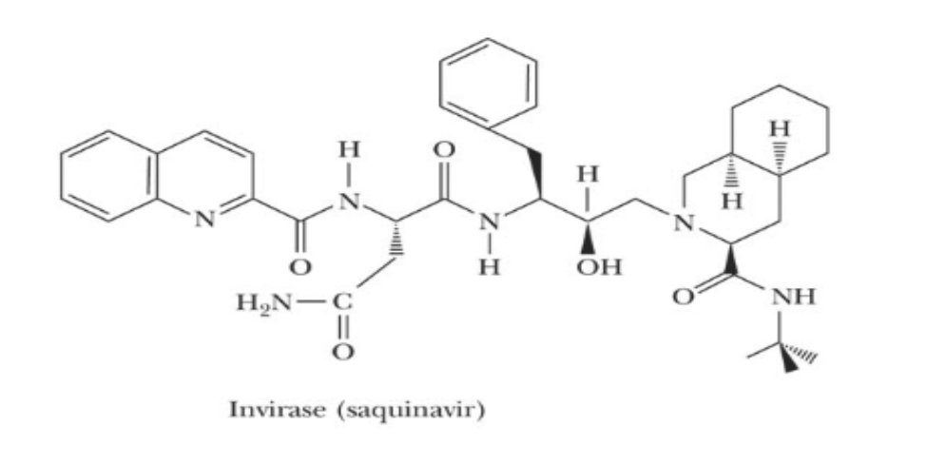

BIOL/CHEM 6352 Name__________________________
Fall 2010
EXAM 2

Additional Questions for BIOL 6352 grad students (Answer on this page, sign above, and turn in with your Scantron sheet):

  - Name the enzyme and specific amino acid residue in the enzyme targeted by organophosphorus insecticides? Why are they toxic to insects but not animals?

  - Write the formula for initial velocity of an enzyme-catalyzed reaction as a function of [S] as derived by Briggs and Haldane using the steady-state assumption. Explain how this formula is the basis for assay of enzyme concentration.

  - a) Why do analogs of the transition state make better competitive inhibitors than substrate analogs?
b) Why is it important that ΔG for binding of S to E not be too large?

